PROJECT REPORT ON DREAM HOME REALTY

# INTRODUCTION

### 1.1 OVERVIEW

My project name is Dream Homes Realty (construction and contracting-Industry. A dream home is a place that meets – if not exceeds – your every need, and even needs that you didn't know you had. It reflects your personal style, and fills you with a sense of calm.

### 1.2 PURPOSE

Builders oversee, coordinate and work on the construction, repair and renovation of homes and other buildings. They may also manage entire projects.

Builders must comply with strict safety regulations, including using and wearing protective equipment and ensuring the construction site is safe.

It is important to keep in mind that building your ideal house requires months of time and labor of individuals who understand the customer’s emotional connection to their house and are prepared to accept responsibility for the same. In this article, we have put together five Reasons, you should hire a professional to build your dream home.

# PROBLEM DEFINITION & DESIGN THINKING

* 1. Empathy Map

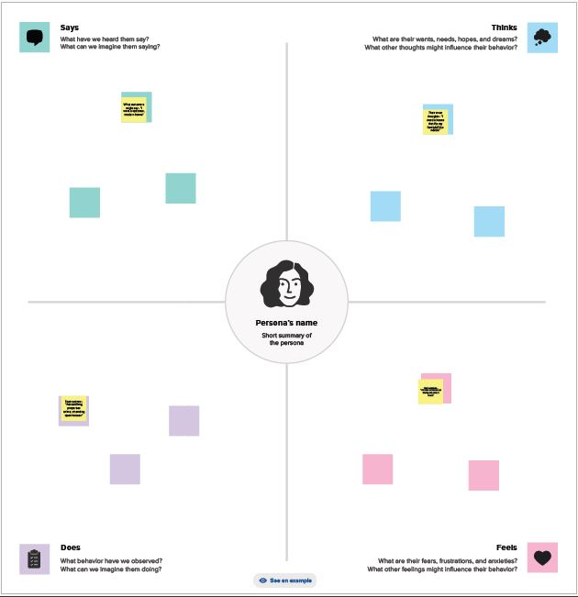

* 1. **Ideation & Brainstroming map**

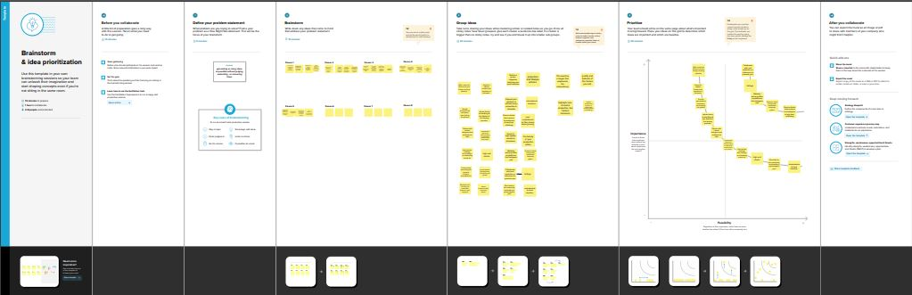

# RESULT

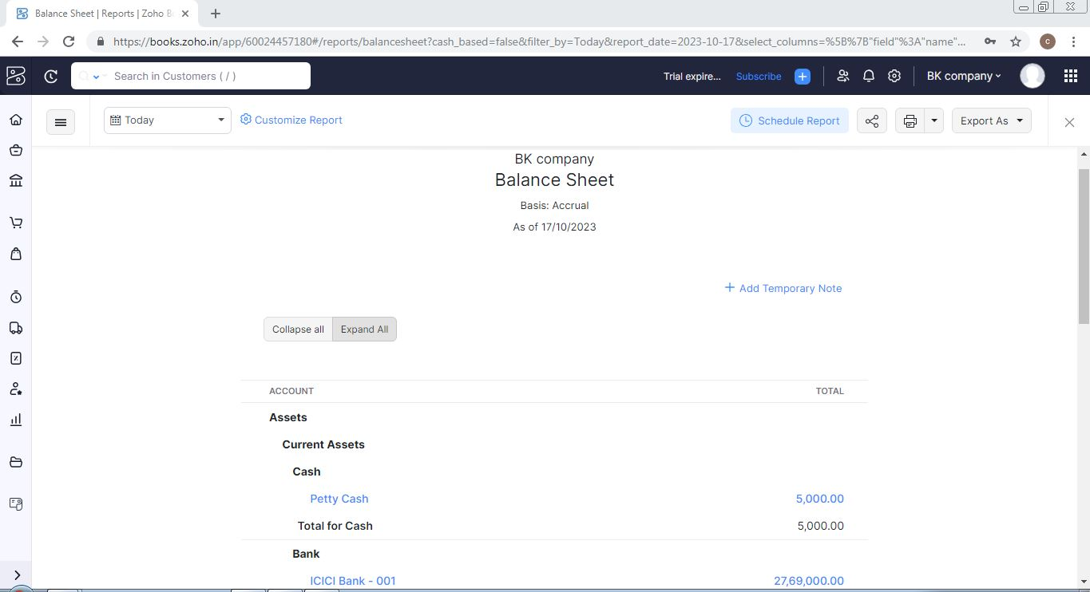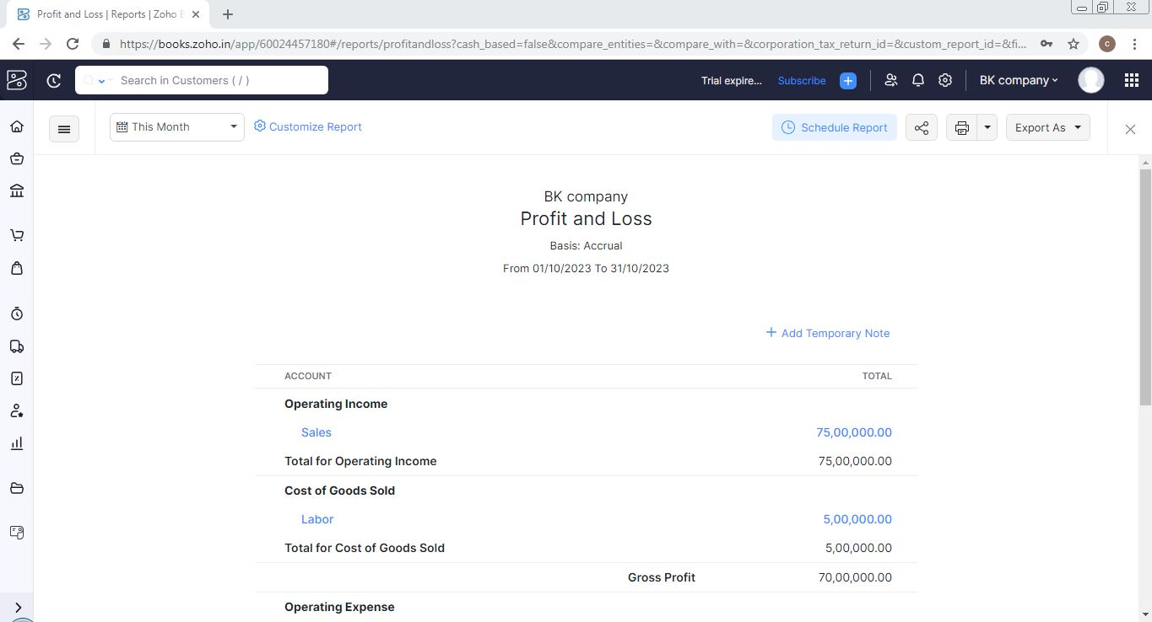

1. **ADVANTAGES & DISADVANTAGES**

## Advantages:

Grade A developers are known for their commitment to quality construction and use of high-quality materials. They use materials that are strong, durable, and long-lasting, ensuring that the home will stand the test of time. They also use the latest building techniques to provide energy-efficient and eco-friendly homes. This means that buyers can expect their homes to be built to a high standard, providing a senseof security and comfort for you and your family.

## Disadvantages:

You are the only one who is going to decide on building the house, you have to decide everything from construction to paperwork. In such a situation, you have to bear the loss, in case it happens in choosing the wrong location, overprice building material, and expensive labor cost.

# APPLICATIONS

**GIT HUB AND ZOHO BOOKS** are used to applied the solution.

# CONCLUSION

My dream is to live in a large, independent house surrounded by a large garden filled with flowers and trees. I don't want to live in an apartment building. Rude neighbours make too much noise in the middle of the night sometimes. My dream home would be outside the city where I can find true peace and happiness.

**7.Future Scope**

Various reports suggest that the property market in India will exhibit a **compound annual growth rate of 9.2% during the period between 2023 and 2028**. According to industry veterans, 2023 will be a momentous year for the industry. In 2021, the size of the Indian property market was USD 200 billion.